Architecture Document

VENDOR Online MARKETPLACE

Robert Enuta

2021

Contents

Project Assignment 2

1. Context 2

2. Goal of the project 2

3. Scope and preconditions 2

Software Architecture 3

# Project Assignment

## 1. Context

Vendor is an online marketplace where users can sell and buy items. The main purpose of the app is making buying and selling as easy and as safe as possible. This is achieved by allowing the user to rate the experiences they had with others and making it obvious when something shady is happening. Users will be dissuaded to interact with malicious sellers and if an account keeps getting reported it will be banned from buying or selling anymore.

After selecting an item to buy, the user will enter a conversation with the seller and discuss the details. And after settling on a price and the delivery, the seller is supposed to take care of the rest themselves.

## 2. Goal of the project

The goal of the project is to create an application that makes selling and buying from others easier and safer. The website will take care of the safety of users, allowing customers to focus on finding the perfect deal for them.

## 3. Scope and preconditions

|  |  |
| --- | --- |
| **Inside scope:** | **Outside scope:** |
| 1. Registion of users. | 1. Storing and delivering of items. |
| 1. Registration of products. |  |
| 1. Storing of chats and tranzactions between users. |  |

# Software Architecture

Below are the C4 diagrams that best describe this project.

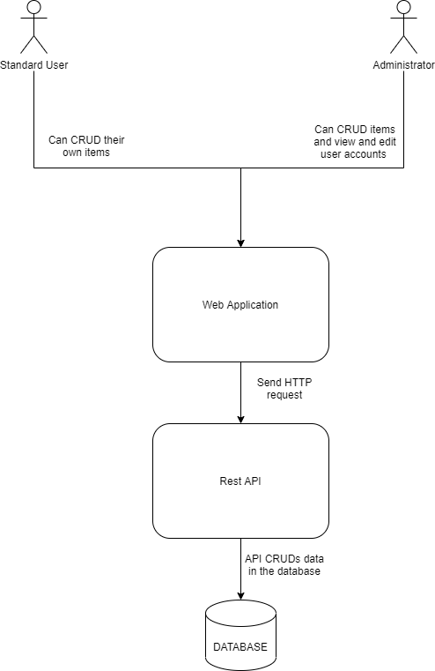

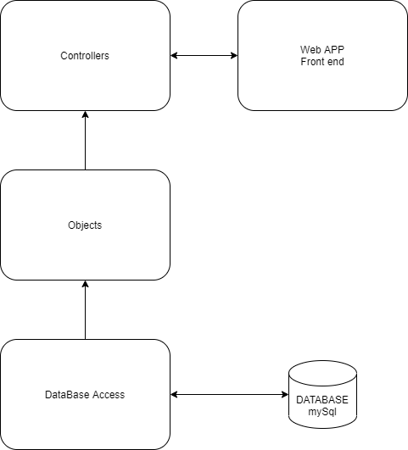

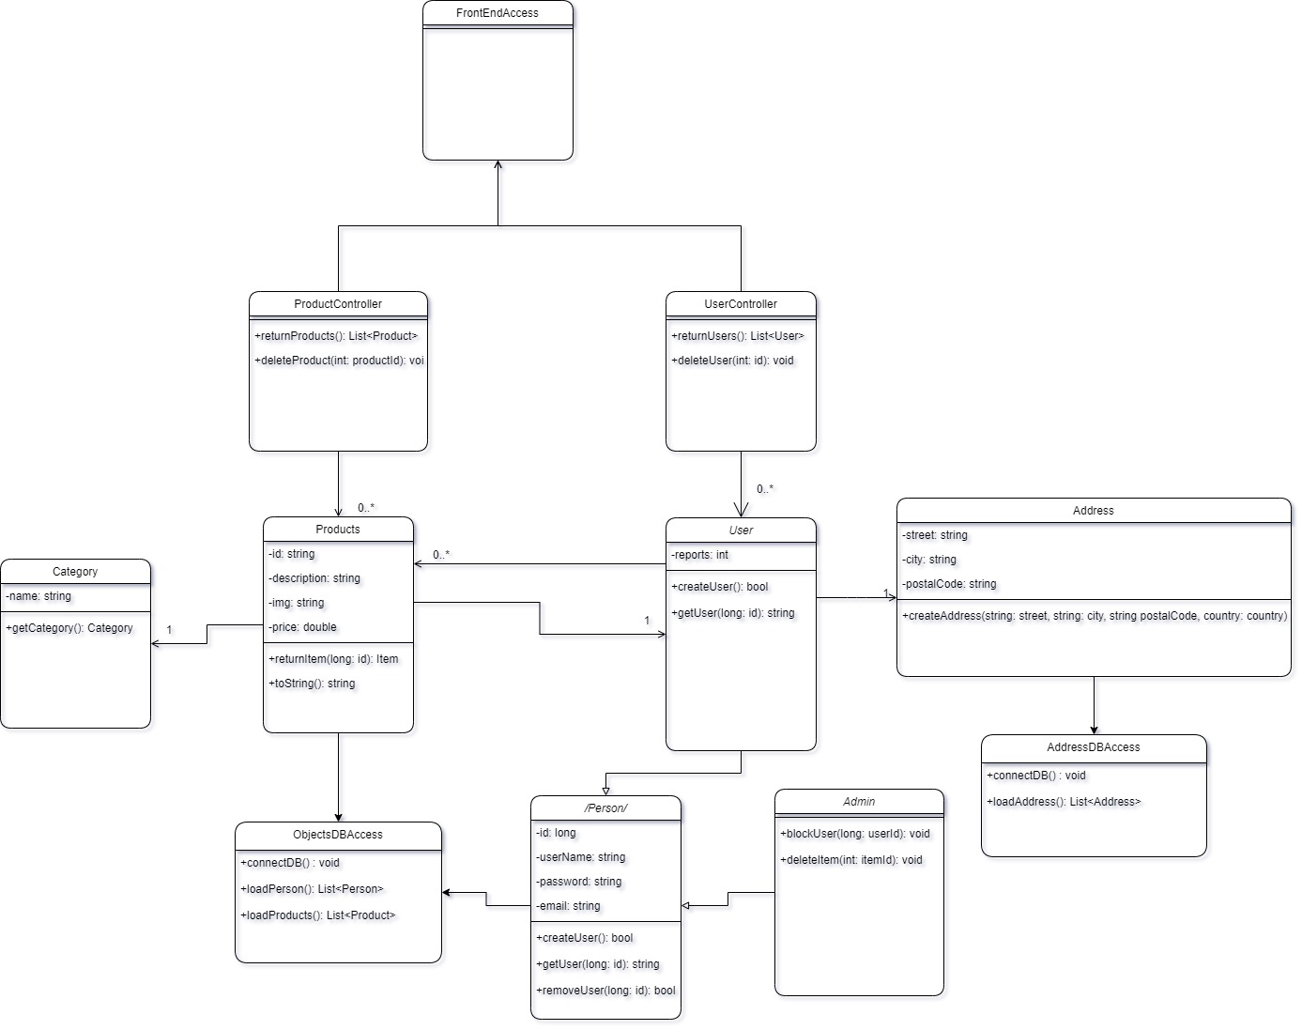

# Diagram Description automatically generatedContinuous Integration Diagram

# Design Decisions

Product Page 

When thinking of designing the frontend website and the project, as a whole, I have looked at what other popular website in this domain are doing and I’ve tried improving on their ideas.  
The website that inspired the look of my project the most was OLX, one of, if not, the most popular and most used websites in Romania when it comes to selling and buying products. OLX acts as an intermediary between sellers and buyers from all around the country.  
Below are images of notes I have initially made for the frontend design.

When doing research on how to best intrigue people to use my website, one of the most common advice was to make the UI easy to use and pleasant to look at, this is reflected in the images above as well. The colours used are not very aggressive, gray being the dominant colour, accompanied by white. The UI is divided, making it easier to find what you are looking for, and the product categories are the most colourful items on the page, making them pop and becoming the centre of attention.